Output screenshots

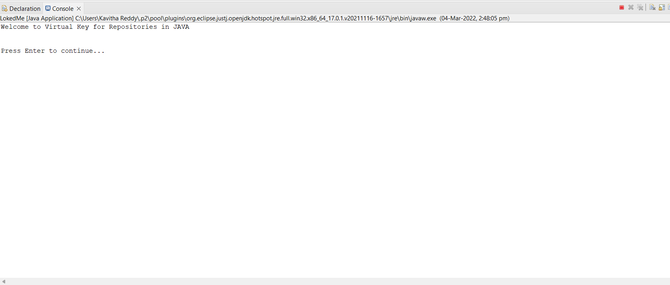

After running of source code this welcome page will display asking press enter to continue

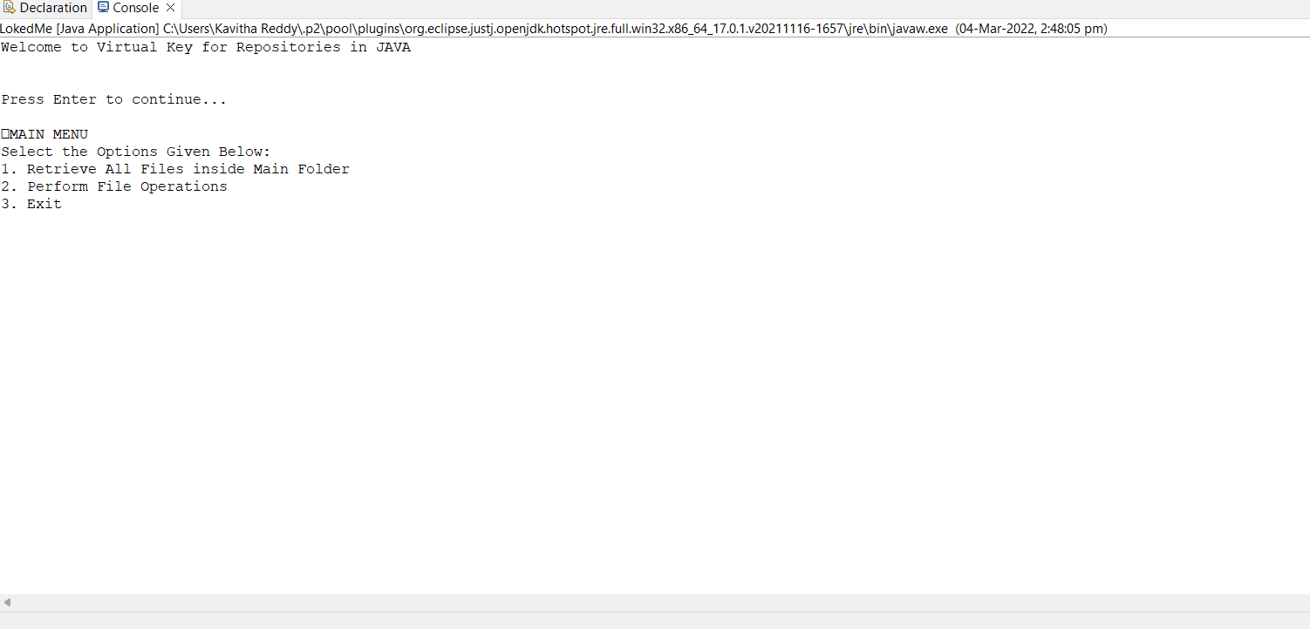

When we press enter button main menu will display with 3 options as show above

We have to select one option

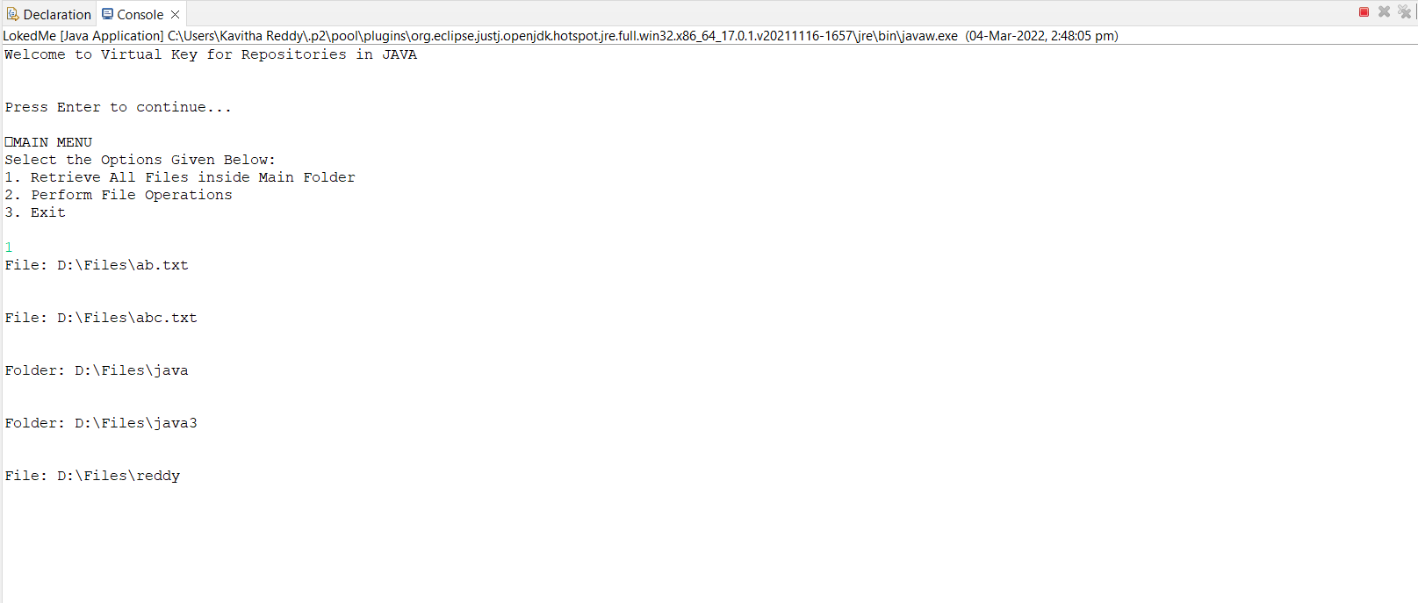

If I select 1st option it retrieve all files inside a folder and it is displaying all files present in my folder

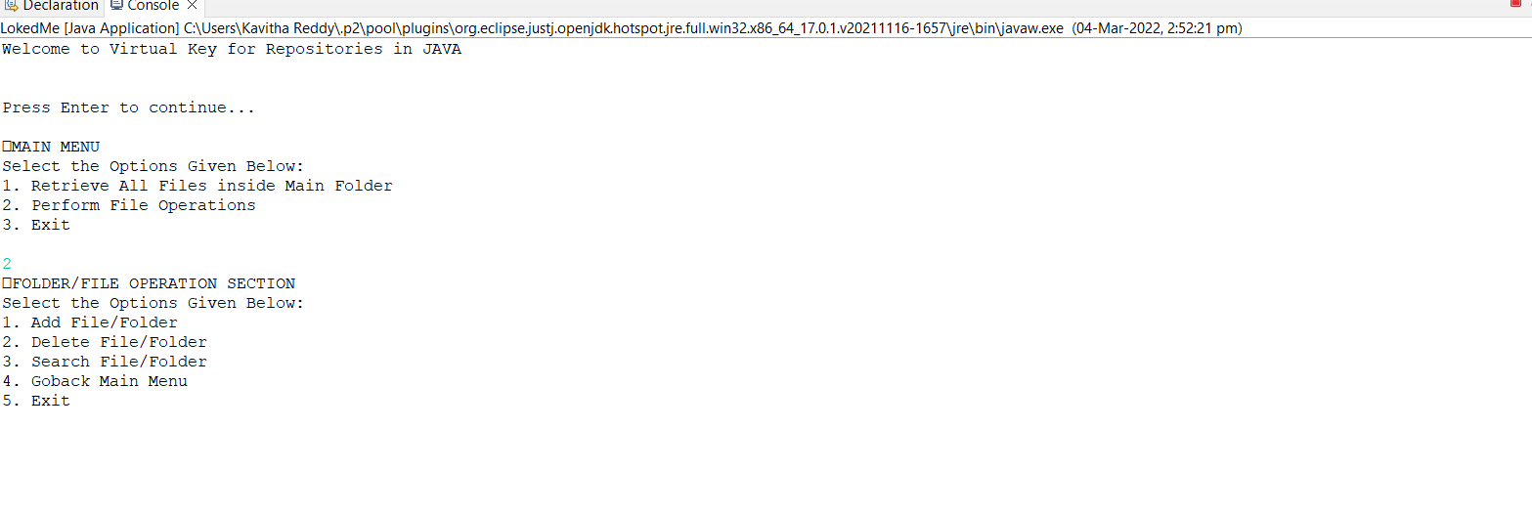

If I select 2nd option there are some sub-options

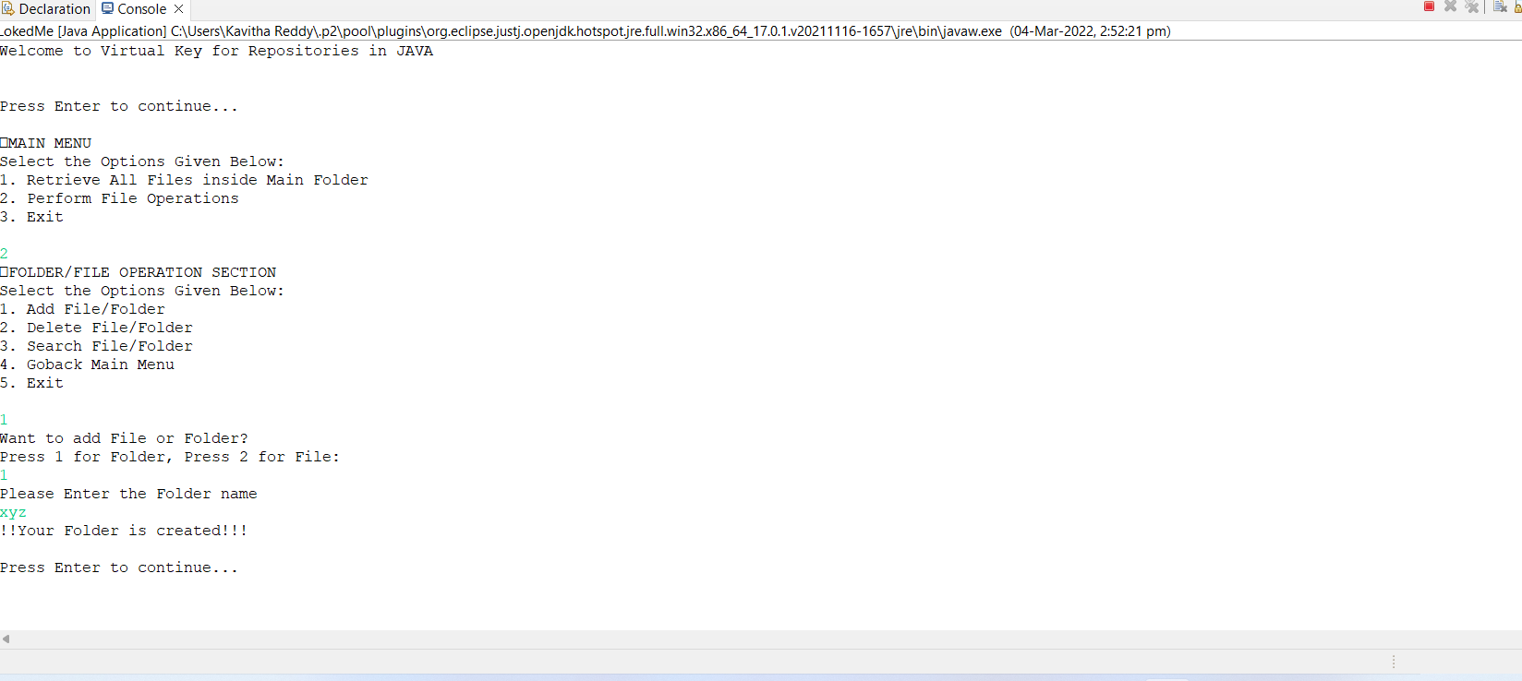

I selected 1st option to add folder

It displayed one message that we want add file or folder now I want add folder so, I selected 1 and I add my folder name as xyz. My folder is created

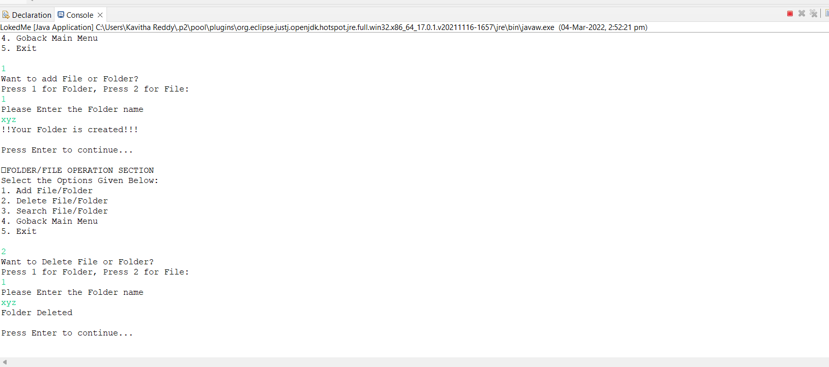

Now I selected 2nd option to delete folder and I want to delete my xyz folder so I mentioned that my folder deleted

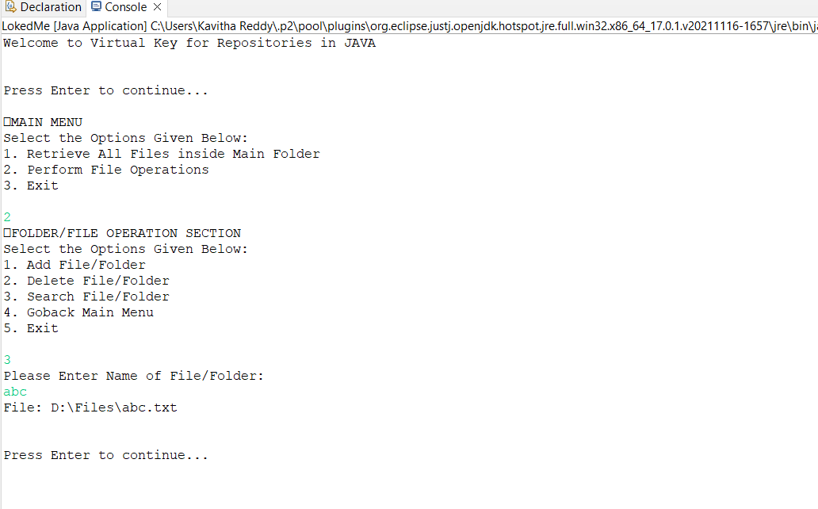

Now I selected 3rd option to search one folder it is asking enter name of folder to search I entered abc and folder is displayed.

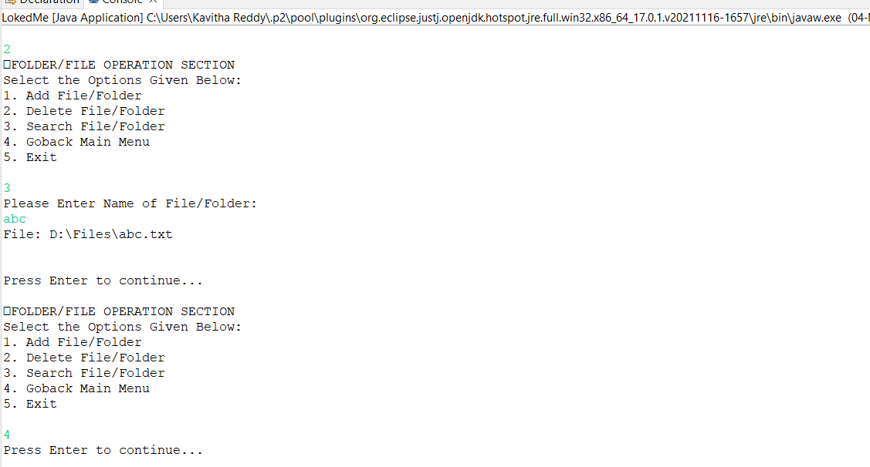

I selected 4th option to go back to menu

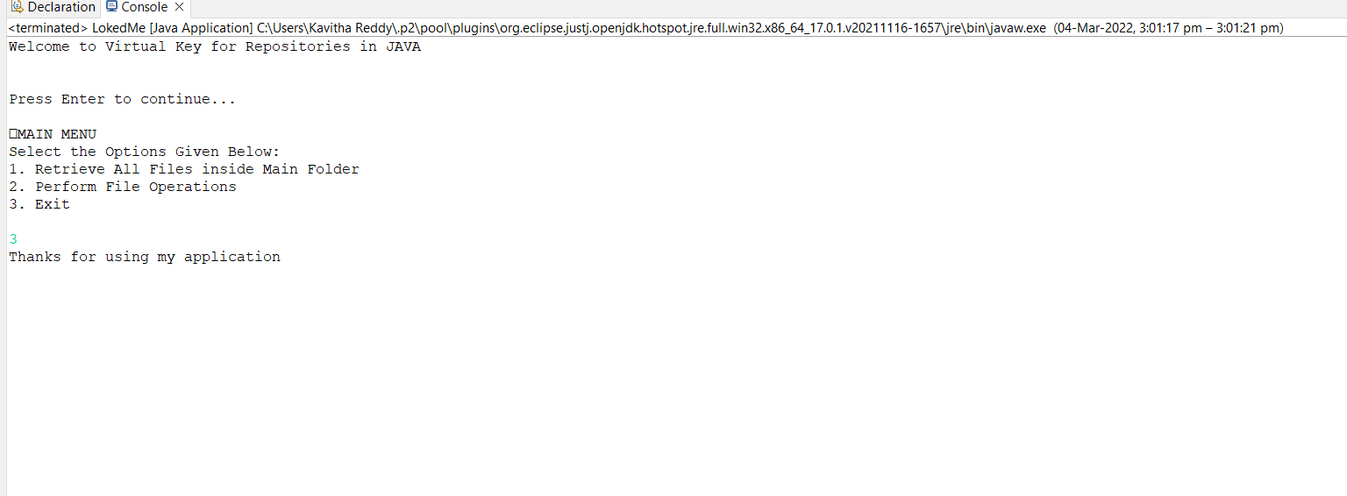

I selected 5th to exist from application